Palette knife Workshop
March 30, 2018-03-18
Workshop is from 10:30-3:00pm with 10-15 min break
Location is Location: 16415 - 83 Ave (right side entrance)

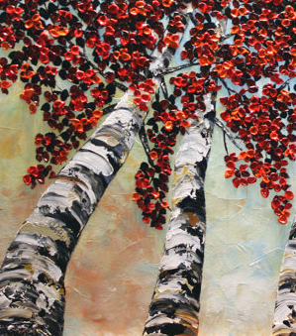
Supplies list:
Canvas: 12x24in or 16x20in
Palette knife 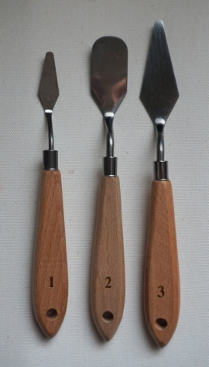 #1, 2 and 3
Paints: Titanium White, Cobalt Blue, Cadmium Yellow, Burnt Sienna, Yellow Ochre, Raw Umber, Cadmium Red Hue, Lamp Black
Brush “Moderna” #6
Rugs, wax paper, inside shoes, snack

