Palette Knife Workshop
June 30, 2018-03-18
“ Misty Walk”
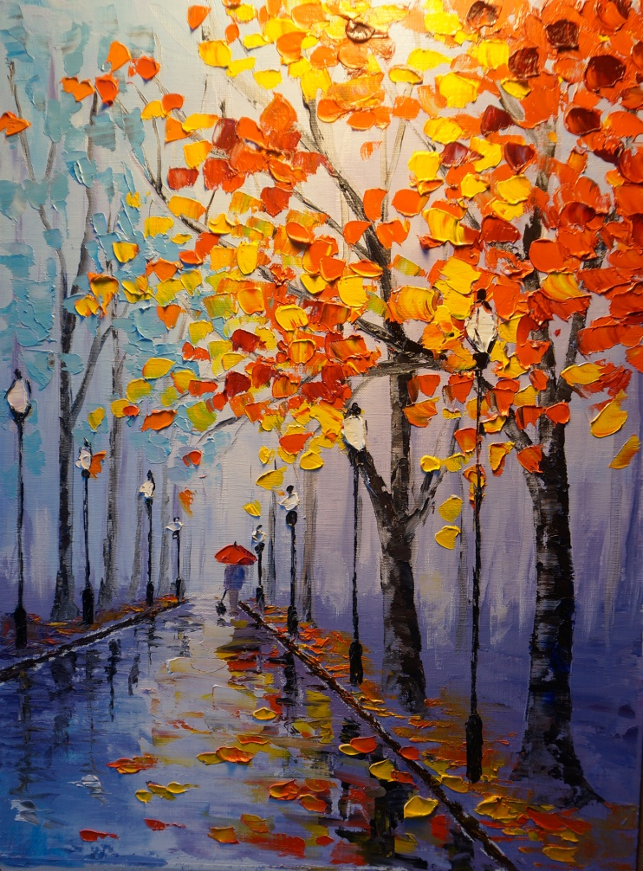
Workshop is from 10:30-3:00pm with 10-15 min break
Location is Location: 16415 - 83 Ave (right side entrance)

Supplies list:
Canvas: 16x20in or 20x24in
Palette knife 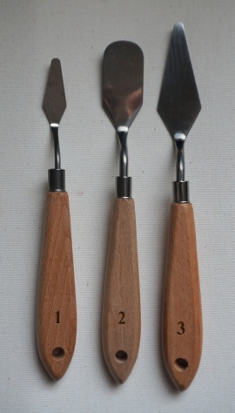 #1, and 3
Paints: Titanium White, Light Blue, Ultramarine, Cadmium Yellow, Burnt Umber, Cadmium Red Hue, Lamp Black, Crimson
Brush “Moderna” #4
Cloth Rags, inside shoes, snack, coffee and tea provided
