Portrait Oil class
Supplies list
Sketchbook, watercolor pencil, pastel pencil, regular pencil, eraser, rugs, seizers, string
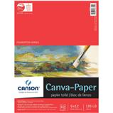”Canson” canvas - paper 12x16”
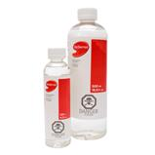Solvent
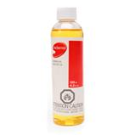Linseed oil
,
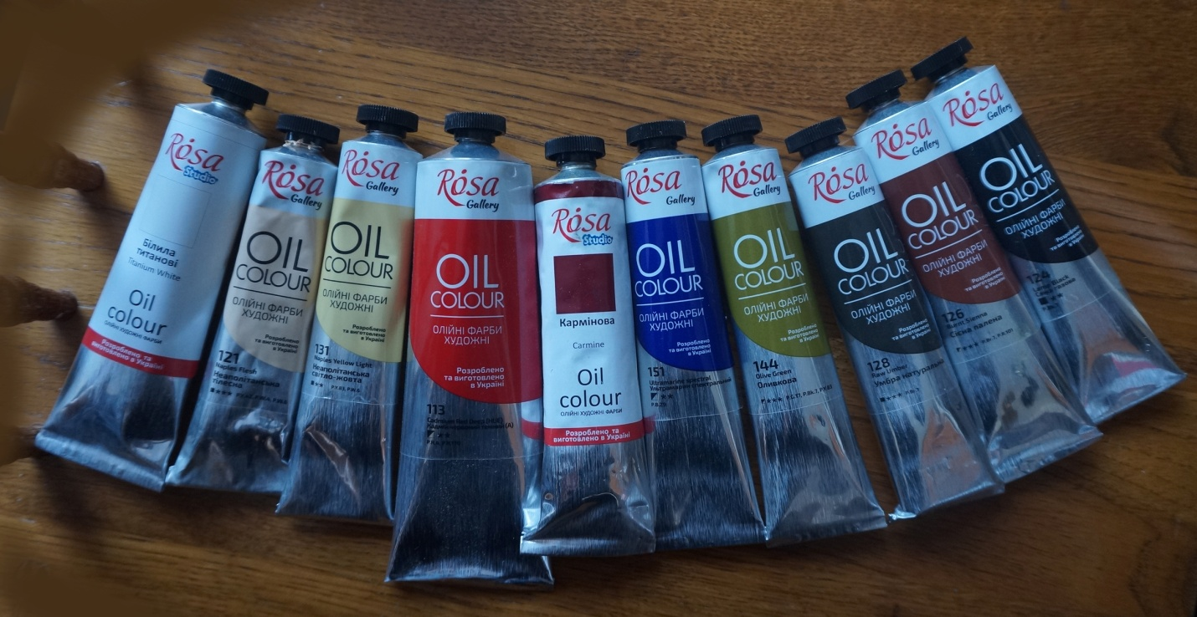You can purchase paint I distribute in class “Rosa”- 45ml-$9.00, 60ml-$10.00 or 100ml-$11.00
Or find similar in any art supplies store: Titanium White, Naples Flesh, Naples Yellow Light, Cadmium Red Deep(HUE), Carmine or Crimson, Ultramarine Spectral, Olive Green, Raw Umber, Burnt Sienna, Lamp Black
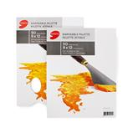Wax paper for painting or Wax paper for baking in Dollarstore
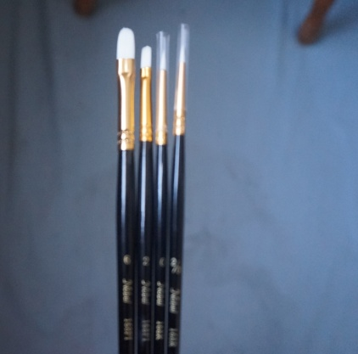 Brushes “Nobel” #6, 4, 2, 0, 2/0

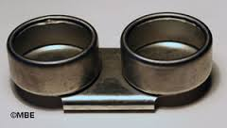 Container for linseed oil and solvent, or any jug you like
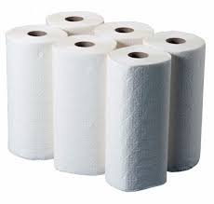 Rugs or paper towels to whip your brushes. Happy Painting,

See you ready for our classes!!!
Happy Painting!!!
Svetlana Kanyo
www.MastersArtAcademy.com
www.kanyoart.com
YouTube: www.youtube.com/user/AlbertaArtsAcademy
Instagram: www.instagram.com/svetlanakanyo/

